**Object Oriented Programming**

***Task #4***

**Report**

**Problem Statement:**

Write an object oriented C++ program for Text Editing. The program should have the following features:

* To open a text file and show its contents on the screen.
* To count and print total number of characters, words and lines of the text in the file.
* To insert new text at a particular position in the text file.
* To delete text from a particular position in the text file.
* To search/find a word in the text file.
* To replace a word in the text file.
* To save the modified text file.

Write an interactive, command-driven program to test your Editor.

**Objectives:**

* To show how file handling can be achieved through OOP (classes and objects)
* To show how different operations in a problem statement can be converted into class member functions.
* To create a file editor that is completely independent of the file being modified.
* To create a file editor that allows user the complete freedom to choose which file to edit.
* To show how a string functions like **erase, replace and find** can be used to edit a text file.
* To create a file editor that also takes data security and memory consumption into consideration while working on files.
* To build a user-friendly program that allows the user to carry out whatever operations they want to.

**UML diagram:**

|  |
| --- |
| FileManager |
| **-** inObj : ifstream  **-** outObj : ofstream  **-** fileName : string |
| +FileManager ()  + FileManager (n : string)  + openAndPrint() : void  + count() : void  + insertData() : void  + deleteData() : void  + findWord() : void  + replaceWord() : void  + modifyAndSave() : void |

**Source Code:**

#include <iostream>

#include <fstream>

#include <string>

#include <stdlib.h>

using namespace std;

class FileManager

{

private:

ifstream inObj;

ofstream outObj;

string fileName;

public:

FileManager() : fileName("1.txt")

{}

FileManager(string n) : fileName(n)

{}

void setFileName(string n)

{

fileName = n;

}

void openAndPrint();

void count();

void insertData();

void deleteData();

void findWord();

void replaceWord();

void modifyAndSave();

};

int main()

{

FileManager j;

int option;

string file;

cout << "\n\t\t\t\t\t\tWelcome to Text File Manager!\n\n\n";

cout << "\t\t\t\tPlease enter the name of the file you want to open: ";

getline(cin, file);

j.setFileName(file);

cout << "\n\n\tFile contents: \n\n";

j.openAndPrint();

j.count();

while (1)

{

cout << "\n\n\t\t\t\t\tEnter 1 to insert data into the file,\n\t\t\t\t\t 2 to delete data from the file,\n";

cout << "\t\t\t\t\t 3 to find a word in the file,\n\t\t\t\t\t 4 to replace a word in the file,\n";

cout << "\t\t\t\t\t 5 to modify the file,\n\t\t\t\t\t or enter 0 to exit\n\n\t\t\t\t\t\t\t ";

cin >> option;

switch (option)

{

case(0):

system("CLS");

cout << "\n\n\n\n\n\n\n\n\n\n\n\n\n\n\t\t\t\t\t\t Goodbye!\n\n\n\n\n\n\n\n\n\n\n\n";

exit(0);

case(1):

j.insertData();

system("CLS");

cout << "\n\n\tNew file contents: \n\n";

j.openAndPrint();

j.count();

break;

case(2):

j.deleteData();

system("CLS");

cout << "\n\n\tNew file contents: \n\n";

j.openAndPrint();

j.count();

break;

case(3):

system("CLS");

j.findWord();

break;

case(4):

system("CLS");

j.openAndPrint();

j.replaceWord();

system("CLS");

cout << "\n\n\tNew file contents: \n\n";

j.openAndPrint();

j.count();

break;

case(5):

j.modifyAndSave();

system("CLS");

cout << "\n\n\tNew file contents: \n\n";

j.openAndPrint();

j.count();

break;

}

}

}

void FileManager::openAndPrint()

{

string line;

inObj.open(fileName, ios::in);

if (inObj.good())

{

while (getline(inObj, line))

{

cout << line << endl;

}

inObj.close();

}

else

{

cout << "\n Sorry, the specified doesn't exist.";

}

}

void FileManager::count()

{

int characters = 0, words = 0, lines = 0;

string tempFileData;

inObj.open(fileName, ios::in);

if (inObj.good())

{

while (getline(inObj, tempFileData))

{

++lines;

characters += tempFileData.length();

for (int i = 0; i < tempFileData.length(); ++i)

{

if (tempFileData[i] == ' ' || i == (tempFileData.length() - 1))

{

++words;

}

}

}

}

inObj.close();

cout << "\n\nTotal characters: " << characters;

cout << "\nTotal words: " << words;

cout << "\nTotal lines: " << lines << endl;

}

void FileManager::insertData()

{

int linePos, charPos, lineCounter = 0;

string originalLine, line, substring;

inObj.open(fileName);

if (inObj.good())

{

cout << "\n\n Enter the line number in which you want to insert new data: ";

cin >> linePos;

for (int i = 0; i < linePos; ++i)

{

getline(inObj, line);

}

inObj.close();

originalLine = line;

cout << endl << " '" << originalLine << "'" << endl;

cout << "\n Enter the character position number from where you want to insert new data: ";

cin >> charPos;

--charPos;

cout << "\n Enter the data you wish to insert: ";

cin.ignore();

getline(cin, substring);

originalLine.insert(charPos, substring);

inObj.open(fileName, ios::in);

outObj.open("2.txt", ios::trunc);

while (!inObj.eof()) //Making a copy of file but with updated data. I could have also used strings to stora all lines of the file but that would consume too much memory and hence would be really inefficient

{

++lineCounter;

getline(inObj, line);

if (lineCounter != linePos)

{

outObj << line << endl;

}

else

{

outObj << originalLine << endl;

}

}

inObj.close();

outObj.close();

inObj.open("2.txt", ios::in);

outObj.open(fileName, ios::trunc); //Erasing old data from original file

while (!inObj.eof()) //Sending new data back to original file from copy file because i dont want to delete and rename file in every execution as that could create a lot of waste and the old file would also be accessible in "Recycle bin" which is not a very good thing from data security perspective

{

getline(inObj, line);

outObj << line << endl;

}

inObj.close();

outObj.close();

outObj.open("2.txt", ios::trunc); //Erasing data from copy file. Sound move from both data security and memory consumption perspectives.

outObj.close();

;

}

else

{

cout << "\n Sorry, the file could not be opened.";

}

}

void FileManager::deleteData()

{

int linePos, charPos, len, lineCounter = 0;

string line, originalLine;

inObj.open(fileName);

if (inObj.good())

{

cout << "\n\n Enter the line number from which you want to delete data: ";

cin >> linePos;

for (int i = 0; i < linePos; ++i) //Picking the line that needs data deletion

{

getline(inObj, line);

}

inObj.close();

originalLine = line;

cout << endl << " '" << originalLine << "'" << endl;

cout << "\n Enter the character position number from where you want to delete data: ";

cin >> charPos;

--charPos;

cin.ignore();

cout << "\n Enter the number of characters you want to delete: ";

cin >> len;

originalLine.erase(charPos, len);

inObj.open(fileName);

outObj.open("2.txt", ios::trunc);

while (!inObj.eof()) //Making a copy of file but with updated data

{

++lineCounter;

getline(inObj, line);

if (lineCounter != linePos)

{

outObj << line << endl;

}

else

{

outObj << originalLine << endl;

}

}

inObj.close();

outObj.close();

inObj.open("2.txt", ios::in);

outObj.open(fileName, ios::trunc); //Erasing old data from original file

while (!inObj.eof()) //Moving updated data back to original file

{

getline(inObj, line);

outObj << line << endl;

}

inObj.close();

outObj.close();

outObj.open("2.txt", ios::trunc); //Erasing data from copy file

outObj.close();

}

else

{

cout << "\n Sorry, the file could not be opened.";

}

}

void FileManager::findWord()

{

string word, line, filler = "/";

int linePos = 0, charPos = 0, wordLen = 0, check = 0;

cout << "\n\n Please enter the word you want to find: ";

cin >> word;

wordLen = word.length();

inObj.open(fileName);

if (inObj.good())

{

while (!inObj.eof())

{

getline(inObj, line);

if (line.find(word) != -1)

{

check = 1;

charPos = line.find(word);

cout << "\n Word found in line " << linePos + 1 << " at character position " << charPos + 1;

line.replace(charPos, wordLen, filler);

while (line.find(word) != -1) //looking for multiple occurences

{

charPos = line.find(word);

cout << "\n Word found in line " << linePos + 1 << " at character position " << charPos + 1;

line.replace(charPos, wordLen, filler);

}

}

++linePos;

}

inObj.close();

if (check == 0)

{

cout << "\n\n Sorry. The entered word does not exist in file.\n";

}

}

else

{

cout << "\n Sorry, the file could not be opened.";

}

}

void FileManager::replaceWord()

{

int wordPos, wordLen, check = 0;

string word, replacement, line, spaces;

inObj.open(fileName);

if (inObj.good())

{

outObj.open("2.txt", ios::trunc); //Ensuring copy file is empty

outObj.close();

cout << "\n\n Enter the word you want to replace: ";

cin >> word;

wordLen = word.length();

cout << "\n Enter the word you want to replace '" << word << "' with: ";

cin >> replacement;

while (!inObj.eof())

{

getline(inObj, line);

if (line.find(word) != -1)

{

check = 1;

wordPos = line.find(word);

while (wordPos < line.length())

{

line.replace(wordPos, wordLen, replacement);

wordPos = line.find(word);

}

}

outObj.open("2.txt", ios::app); //Creating a separate file because storing all lines in string would consume too much memory and will be really inefficient

outObj << line << endl;

outObj.close();

}

inObj.close();

if (check == 1)

{

outObj.open(fileName, ios::trunc); //Removing all data from original file

inObj.open("2.txt", ios::in);

while (!inObj.eof()) //Sending all data back to original file from copy file because i dont want to delete and rename file in every execution as that could create a lot of waste

{

getline(inObj, line);

outObj << line << endl;

}

outObj.close();

inObj.close();

outObj.open("2.txt", ios::trunc); //removing all data from "2.txt"

outObj.close();

}

else

{

cout << "\n\n Sorry. The entered word does not exist in file.\n";

}

}

else

{

cout << "\n Sorry, the file could not be opened.";

}

}

void FileManager::modifyAndSave()

{

outObj.open(fileName, ios::app);

if (outObj.good())

{

int lines;

cout << "\n\n Please enter the number of lines of data you want to add to the file: ";

cin >> lines;

string* dataLines = new string[lines];

for (int i = 0; i < lines; ++i)

{

cin.ignore();

cout << "\n Enter data for line " << i + 1 << ": ";

getline(cin, dataLines[i]);

outObj << dataLines[i] << endl;

}

delete[] dataLines;

outObj.close();

}

else

{

cout << "\n Sorry, the file could not be opened.";

}

}

**Tools Used: Visual Studio 2019, Microsoft Word**

**Sample Program Outputs:**

Welcome screen:

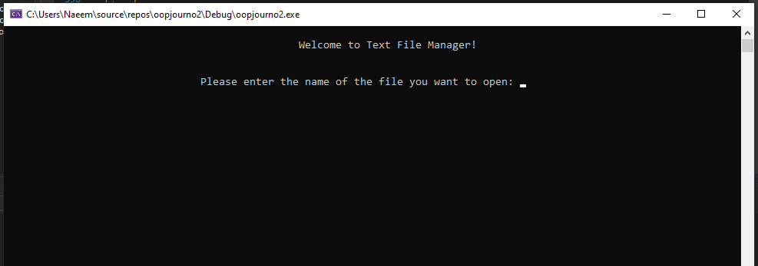

Open, print and count functions (+ Main Menu) :

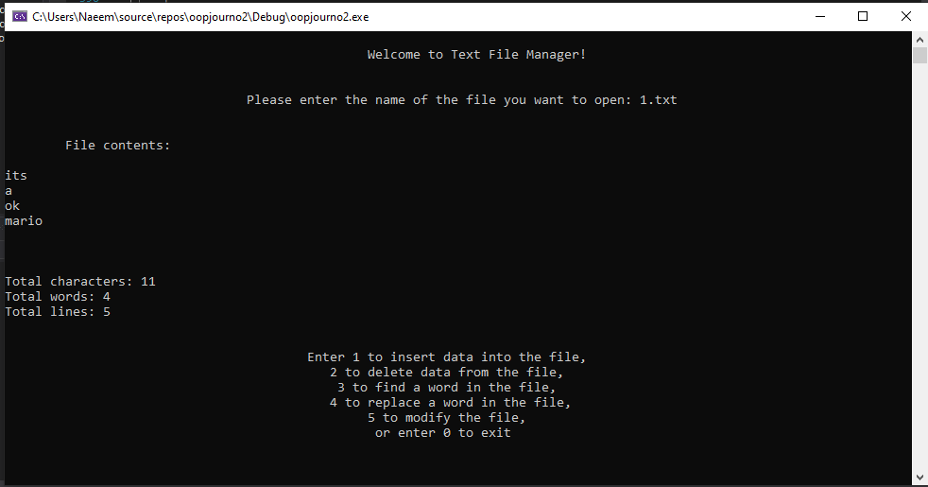

Insert function:

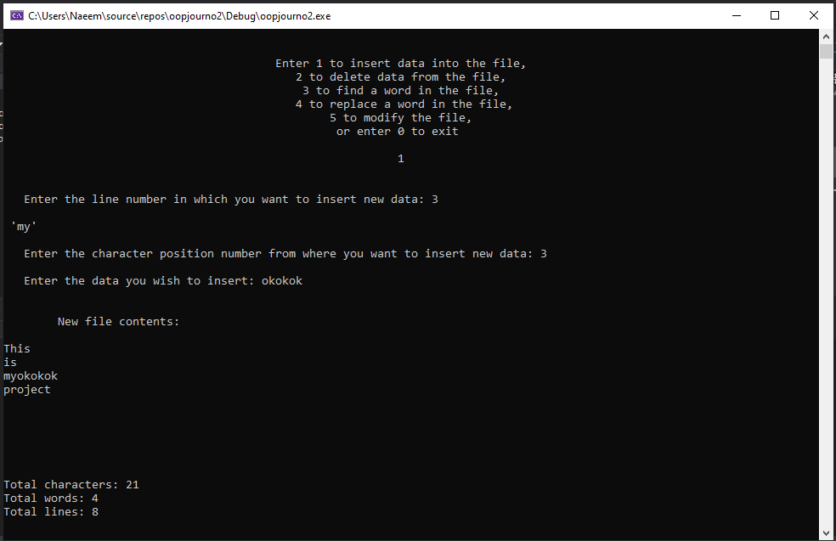

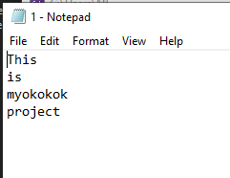Text file before and after insertion

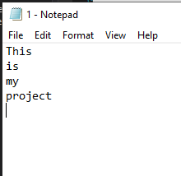

Delete function:

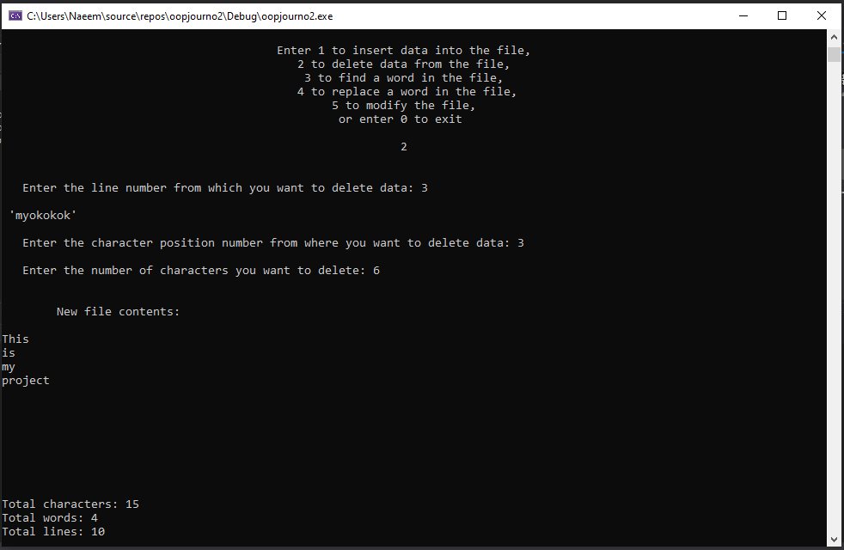

Text file before and after deletion



Find function:

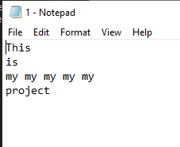 Multiple instances in same line

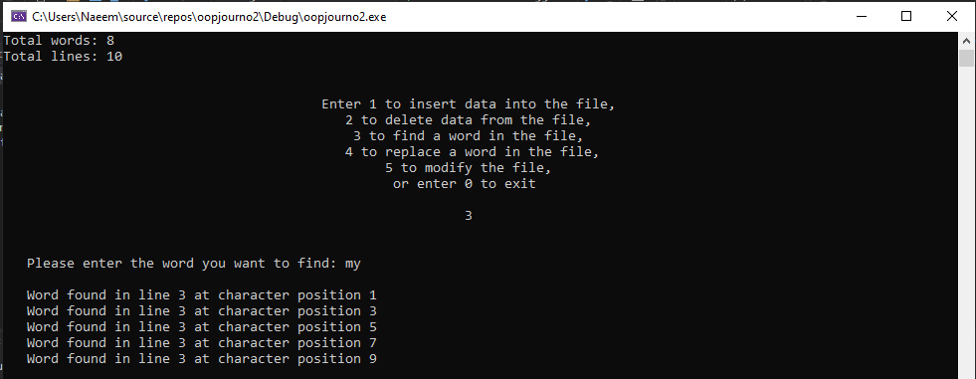

Replace function:

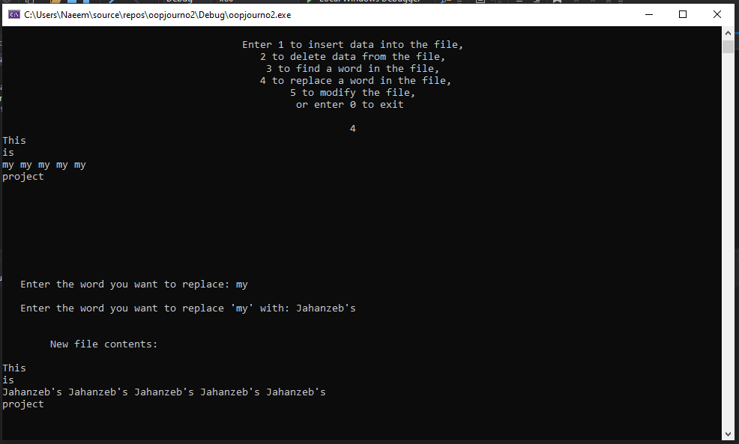

Text file before and after replacing

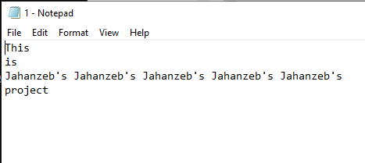

Modify and save function:

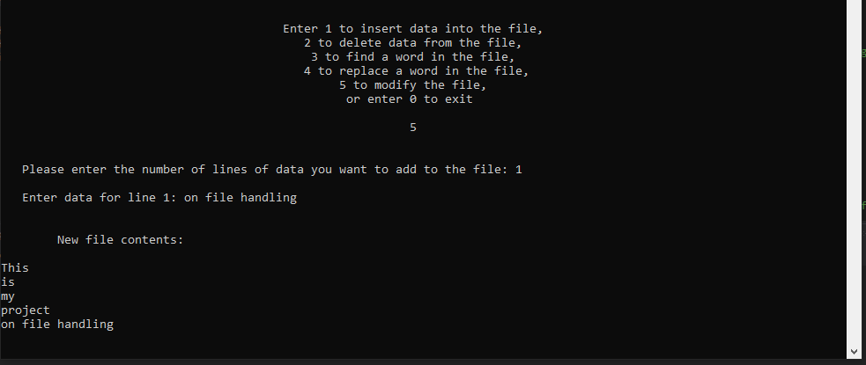

Text file after modifying

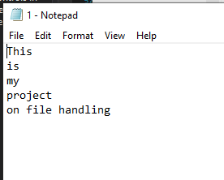

Exit:



Exit Screen:

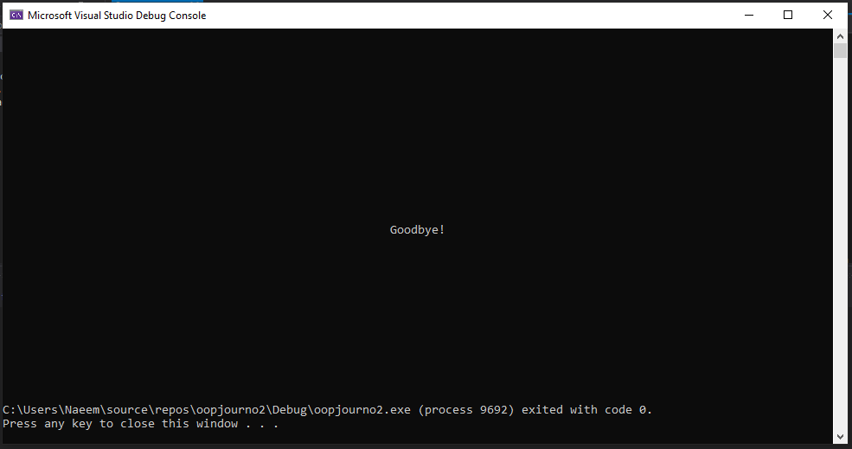

**Conclusion:**

It can be seen that it is indeed possible to create such a text file editor using UML diagram, classes and text files.